- Create user with name Techie and provide sudo access to user.

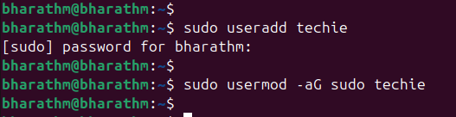

2 Navigate to the home directory.
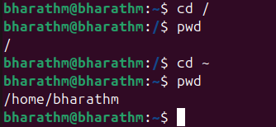

3 Create a new directory.
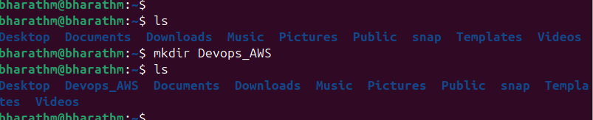

4 List the contents of a directory.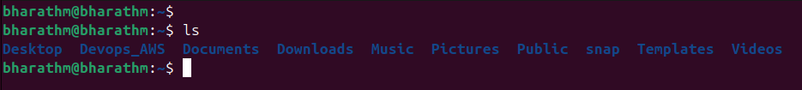

5 Change the current directory.
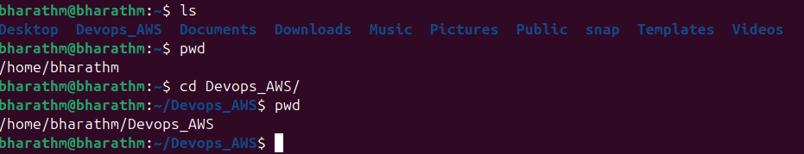

6 Create a new empty file.
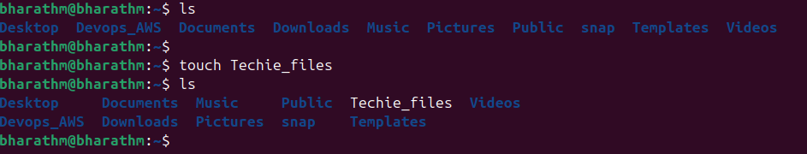

7 View the contents of a file.
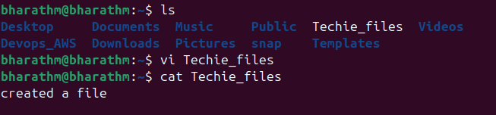

8 Copy a file to another location.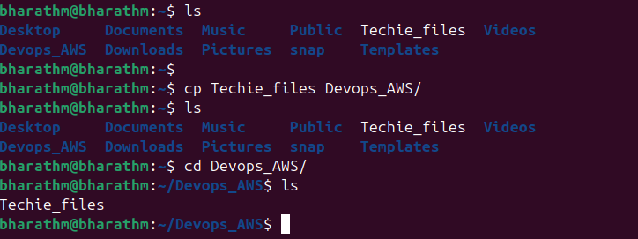

9 Move a file to another location.
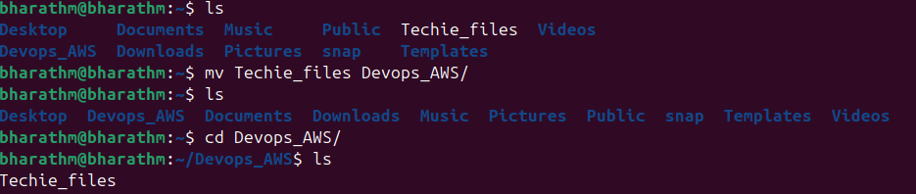

10 Rename a file.
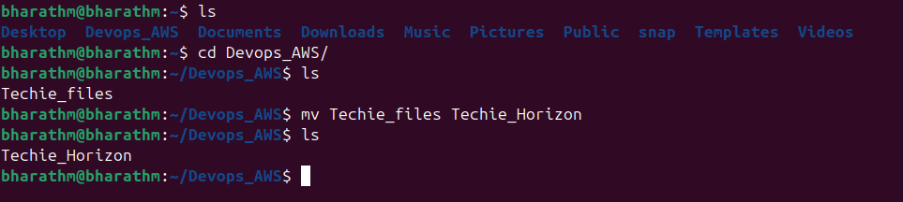

11 Delete a file.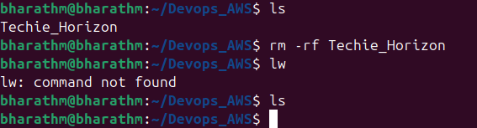

12 Grant or revoke permissions on a file or directory.
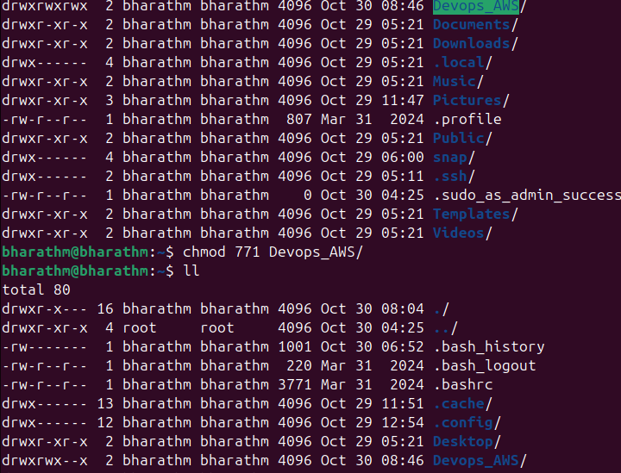

13 View the current date and time.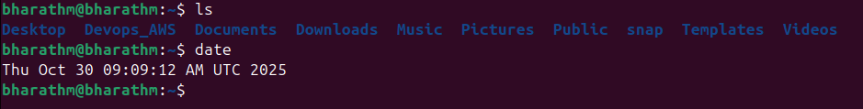
14 Check the system uptime.

15 View the running processes.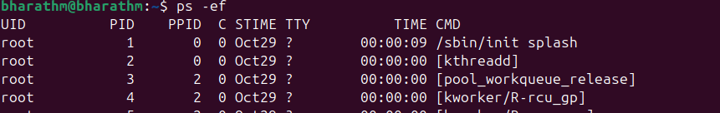

16 Kill a running process.
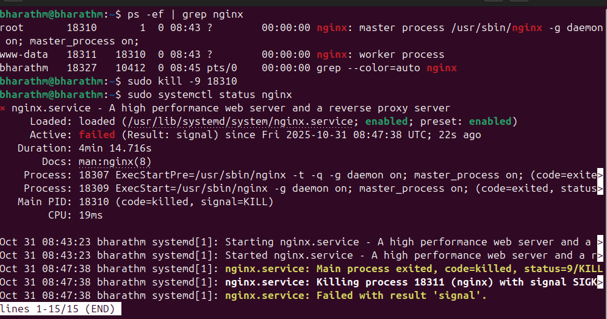

17 Install a package using the package manager
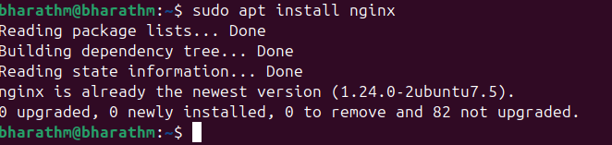

18 Update the system packages.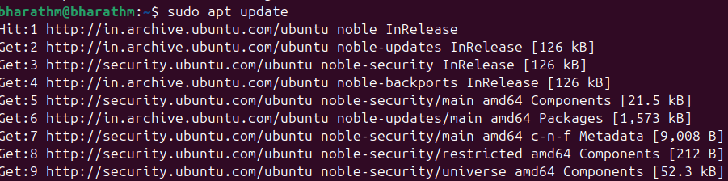

19 Create a symbolic link.
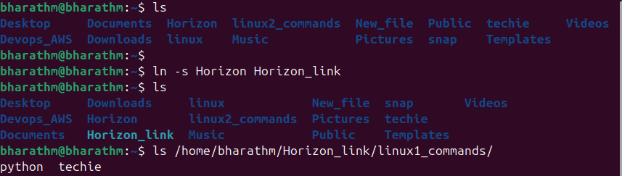

20 Search for files using the find command

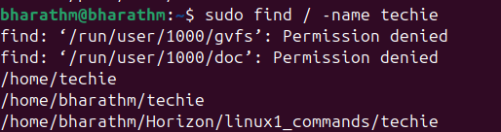

21 Compress and decompress files using tar
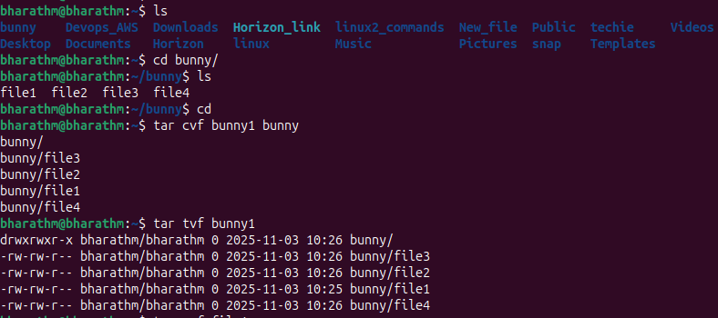

22 Monitor system resources with top or htop.

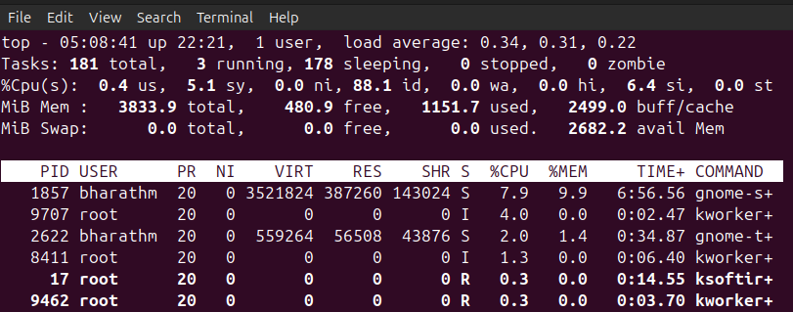
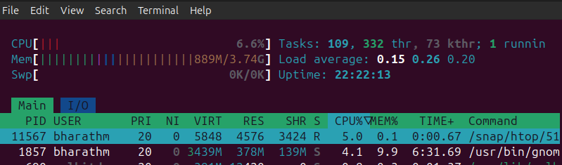

23 Create and manage user groups.

Create a new group groupadd techie_horizon
Add user to the group usermod -aG techie_horizon techie
Check the user added to group: groups techie
remove user from a group: gpasswd -d user groupname
delete group: groupdel groupname
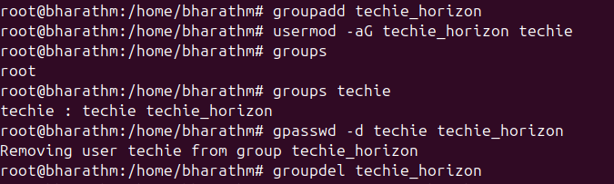

24 Set up SSH password less authentication

25 Monitor log files using tail or grep
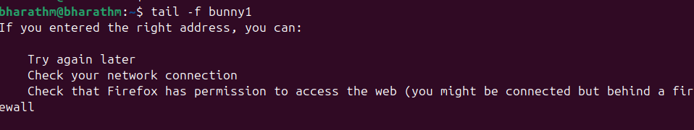

26 Set up a web server (e.g., Apache or Nginx)

27 Configure and secure a MySQL Database
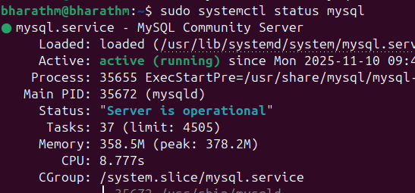

28 Set up a Application Server (e.g.,Apache Tomcat)
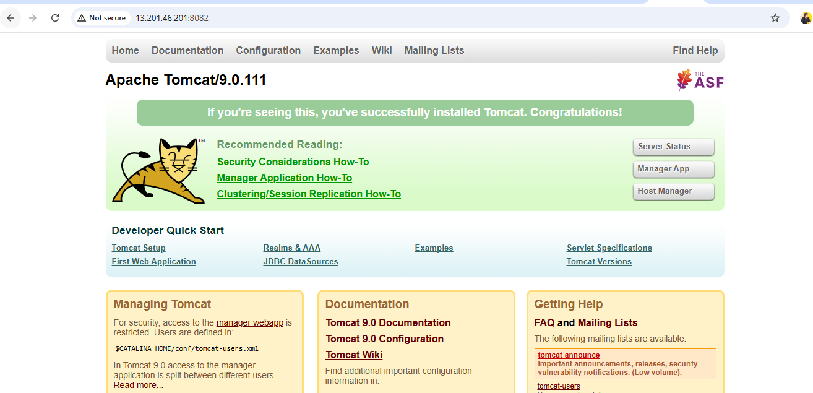

29 create a service file for Apache Tomcat.(Should execute by using systemtctl command)
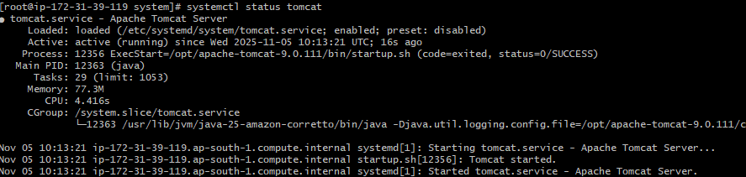

30 Print specific columns from a delimited file
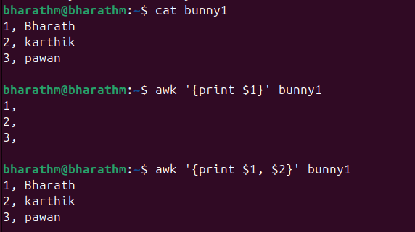
31 Filter and print lines based on a specific pattern or condition
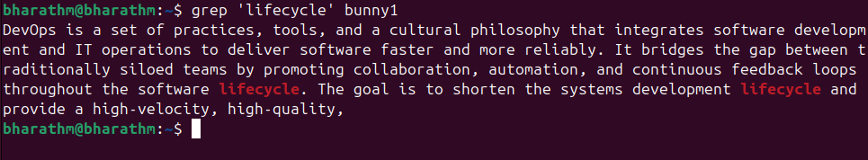

32 Calculate and print the average, sum, or other statistics of a column.
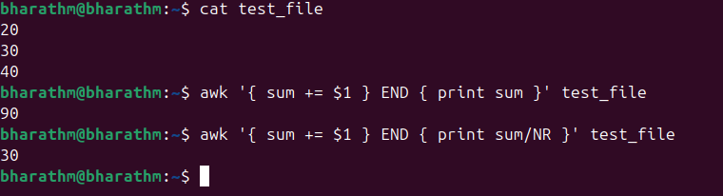

33 Perform string manipulation, such as extracting substrings or changing case.
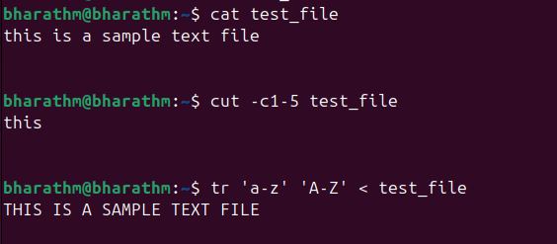

34 Count the occurrences of a specific pattern in a file.
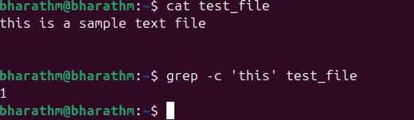
35 Sort lines based on a specific field or column
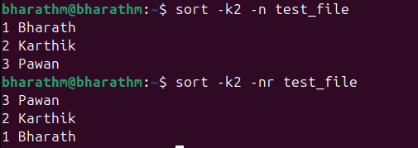

36 Merge multiple files based on a common field or column
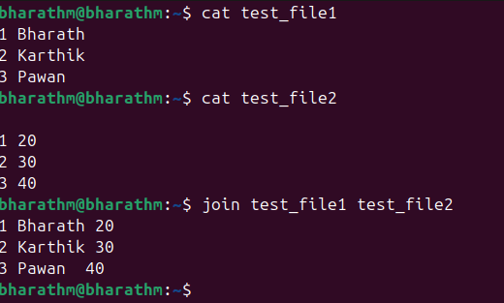

37 Substitute text in a file using search and replace.

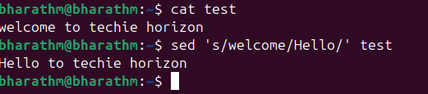

38 Delete specific lines based on a pattern or line number.
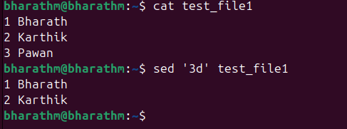

39 Append or insert text before or after a specific pattern or line.

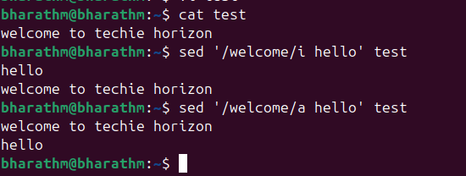

40 Print only specific lines from a file.
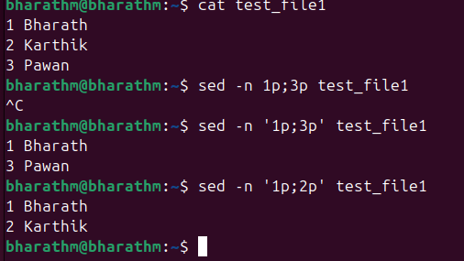
41 Copy file from linux to windows machine
Scp -i (pemkey) ec2-user@ip:/home/file ~/Downloads/
42 5 use cases of AWk and use cases of sed

